**Introduction to Probability**

Definition: Probability measures the likelihood of an event occurring, expressed as a number between 0 and 1.

P(A)=0: Event A is impossible.

P(A)=1: Event A is certain.

**Probability of Event P(E) = [Number of Favorable Outcomes] / [Total Number of Outcomes]**

**Key Terminology**

* Experiment: An action or process that leads to one or more outcomes (e.g., rolling a dice).
* Sample Space (S): The set of all possible outcomes of an experiment.
  + Example: Rolling a dice: S={1,2,3,4,5,6}
* Event: A subset of the sample space, representing one or more outcomes.
  + Example: Event A (rolling an even number): A={2,4,6}.
* Outcome: A single result from the sample space (e.g., rolling a 4).

**Rules of Probability**

**Addition Rule**

The addition rule for probability is a principle that allows you to calculate the probability that at least one of two events will occur. It is defined as the sum of the probabilities of each event, minus the probability that both events occur together. This prevents double-counting the overlap between the events.

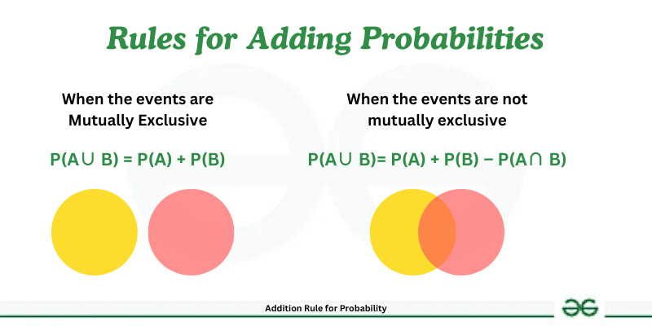

**Mutually Exclusive Events**

Two events, A and B, are said to be mutually exclusive if they cannot occur simultaneously during a single trial.

Example: In a coin toss, the events “Getting Heads” and “Getting Tails” are mutually exclusive because both cannot happen at the same time.

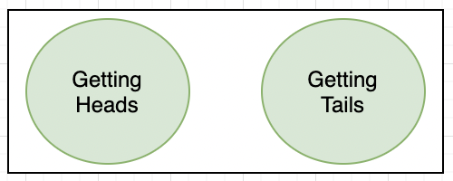

Addition Rule: Since P(A ∩ B) = 0 (no overlap), the formula simplifies to: **P(A ∪ B) = P(A) + P(B)**

Here:

* P(Getting Heads) = 1/2,
* P(Getting Tails) = 1/2,
* P(Getting Heads or Tails) = 1/2 + 1/2 = 1

When the probabilities of all possible events in a sample space are added, their sum is equal to 1.

**Non-Mutually Exclusive Events**

Two events, A and B, are said to be non-mutually exclusive if they can occur simultaneously during a single trial.

Example: Rolling a die, let A represent rolling an odd number ({1, 3, 5}) and B represent rolling a 3 ({3}). In this case, the number 3 belongs to both events, meaning A and B overlap.

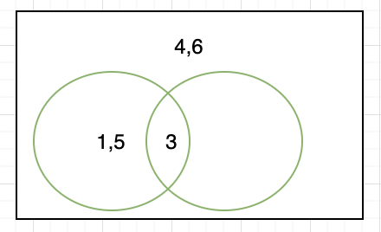

Addition Rule: P(A ∪ B) = P(A) + P(B) − P(A ∩ B)

Here:

* P(A): Probability of rolling an odd number = 3/6 = 1/2,
* P(B): Probability of rolling a 3 = 1/6​,
* P(A ∩ B): Probability of rolling a number that is both odd and 3 = 1/6.

Substitute into the formula: P(A ∪ B) = 1/2 + 1/6 − 1/6 = 1/2.

**Multiplication Rule**

The multiplication rule of probability states that the probability of the joint occurrence of two or more independent events is the product of their individual probabilities.

Mathematically, if A and B are two independent events, then the probability of both events occurring, denoted as P(A∩B), is given by:

**P(A∩B) = P(A) × P(B)**

The multiplication rule is based on the assumption that the events are independent, meaning that the occurrence of one event does not affect the occurrence of the other events.

If A and B are dependent events, then the probability of both events occurring simultaneously is given by:

**P(A ∩ B) = P(B) . P(A|B)**

An urn contains 20 red and 10 blue balls. Two balls are drawn from a bag one after the other without replacement. What is the probability that both the balls drawn are red?

Solution: Let A and B denote the events that the first and the second balls are drawn are red balls. We have to find P(A∩B) or P(AB).

P(A) = P(red balls in first draw) = 20/30

Now, only 19 red balls and 10 blue balls are left in the bag. The probability of drawing a red ball in the second draw too is an example of conditional probability where the drawing of the second ball depends on the drawing of the first ball.

Hence Conditional probability of B on A will be,

P(B|A) = 19/29

By multiplication rule of probability,

P(A∩B) = P(A) × P(B|A)

P(A∩B) = 20/30 × 19/29 = 38/87

**Complement Rule**

Probability of an event not occurring is: P(Ac)=1−P(A)

Example:

If P(A)=0.7

then P(C)=1−0.7=0.3

**Law of Subtraction**

For events 𝐴 and 𝐵, the probability of 𝐴 but not 𝐵 is:

𝑃 ( 𝐴 ∖ 𝐵 ) = 𝑃 ( 𝐴 ) − 𝑃 ( 𝐴 ∩ 𝐵 )

**Inclusion-Exclusion Principle** For three events 𝐴, 𝐵, and 𝐶:

𝑃 ( 𝐴 ∪ 𝐵 ∪ 𝐶 ) = 𝑃 ( 𝐴 ) + 𝑃 ( 𝐵 ) + 𝑃 ( 𝐶 ) − 𝑃 ( 𝐴 ∩ 𝐵 ) − 𝑃 ( 𝐴 ∩ 𝐶 ) − 𝑃 ( 𝐵 ∩ 𝐶 ) + 𝑃 ( 𝐴 ∩ 𝐵 ∩ 𝐶 )

**Odds and Probability**:  
Odds are another way to represent the likelihood of an event. If the probability of an event A is P(A), the odds in favor of A are:



**Conditional Probability**

The probability of occurrence of any event A when another event B in relation to A has already occurred is known as conditional probability. It is depicted by P(A|B).

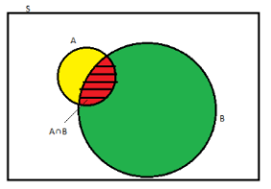

Example:

A deck of cards: What is the probability of drawing an ace, given that the card is a spade?

**Bayes' Theorem**

Bayes’ theorem describes the probability of occurrence of an event related to any condition. It is also considered for the case of conditional probability. Bayes theorem is also known as the formula for the probability of “causes”.

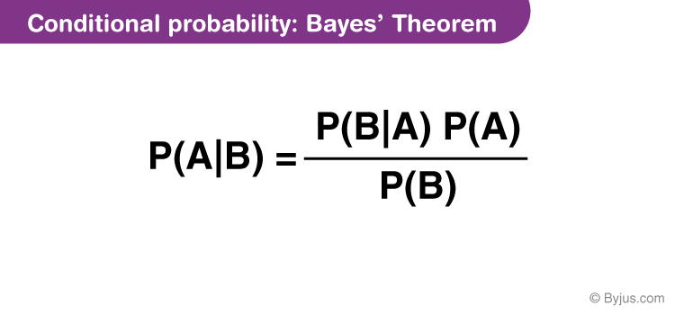

For example: if we have to calculate the probability of taking a blue ball from the second bag out of three different bags of balls, where each bag contains three different colour balls viz. red, blue, black.

A bag I contains 4 white and 6 black balls while another Bag II contains 4 white and 3 black balls. One ball is drawn at random from one of the bags, and it is found to be black. Find the probability that it was drawn from Bag I.

Solution:

Let E1 be the event of choosing bag I, E2 the event of choosing bag II, and A be the event of drawing a black ball.

Then,

P(E1) = P(E2) = 12

Also, P(A|E1) = P(drawing a black ball from Bag I) = 6/10 = 3/5

P(A|E2) = P(drawing a black ball from Bag II) = 3/7

By using Bayes’ theorem, the probability of drawing a black ball from bag I out of two bags,

│

P(E1|A) = P(E1)P(A|E1)P(E1)P(A│E1)+P(E2)P(A|E2)

=12 × 3512 × 35 + 12 × 37

Law of Total Probability Statement

Let events C1, C2 . . . Cn form partitions of the sample space S, where all the events have a non-zero probability of occurrence. For any event, A associated with S, according to the total probability theorem,

P(A)=∑k=0nP(Ck)P(A|Ck)

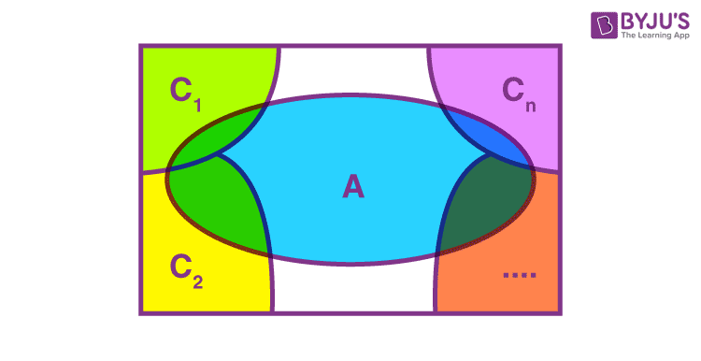

**Permutation**

In mathematics, permutation relates to the act of arranging all the members of a set into some sequence or order.

**Combination**

The combination is a way of selecting items from a collection, such that (unlike permutations) the order of selection does not matter.

**Permutation Formula**

A permutation is the choice of r things from a set of n things without replacement and where the order matters.

#### **nPr = (n!) / (n-r)!**

**Combination Formula**

A combination is the choice of r things from a set of n things without replacement and where order does not matter.

#### 

#### 

| **Permutation** | **Combination** |
| --- | --- |
| Arranging people, digits, numbers, alphabets, letters, and colours | Selection of menu, food, clothes, subjects, team. |
| Picking a team captain, pitcher and shortstop from a group. | Picking three team members from a group. |
| Picking two favourite colours, in order, from a colour brochure. | Picking two colours from a colour brochure. |
| Picking first, second and third place winners. | Picking three winners. |

**Miscellaneous Concepts**

* Probability Trees
  + Probability trees can help visualize problems involving multiple steps, such as conditional probabilities or dependent events.
* Venn Diagrams
  + Use Venn diagrams to illustrate the addition rule, mutually exclusive events, and overlapping events.